Install AR2020 Driver
- Build DeviceTree:
mkdir AR2020-DTS && cd AR2020-DTS
- Place file “ar2020-s2.dts” to this folder
dtc -@ -I dts -O dtb -o ar2020.dtbo ar2020-s2.dts
sudo cp ar2020.dtbo /boot/firmware/overlays/
- Edit “/overlays/config.txt”
sudo nano /boot/firmware/config.txt
- Add these lines:
dtparam=i2c0=on
dtoverlay=ar2020,cam0
dtoverlay=i2c3
dtoverlay=i2c4,pins_6_7,baudrate=400000
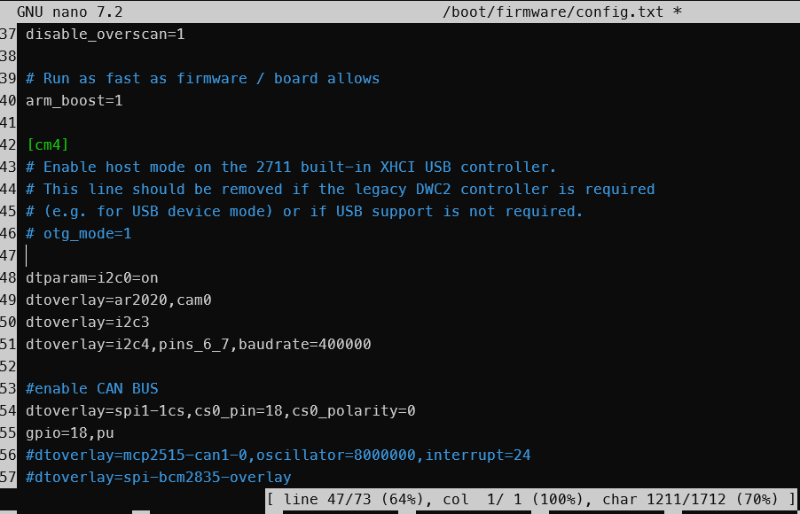
- Check “I2C”
sudo apt install -y i2c-tools
sudo raspi-config #Turn on I2C, Interface Option
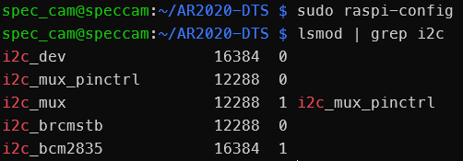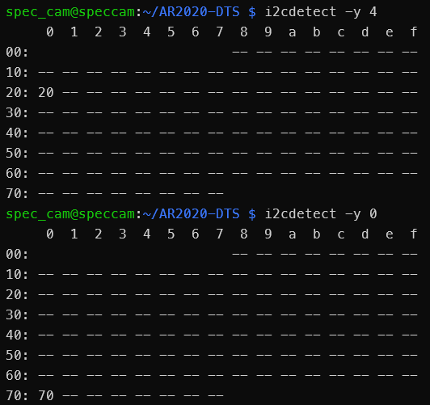
- Switch I2C channel, switch MIPI channel, and enable the Camera (this step must be repeated every time the Camera loses power).
- Add 2 file: “io_script_mipi.py” and “switch_i2c_lane.py”
pip install smbus2
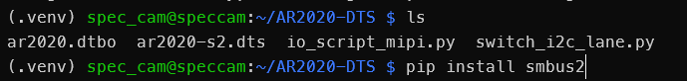
- Turn on Camera[0] ( [U1], [Sen0], MIPI[0], [I2C Channel 0] ) run 2 file python
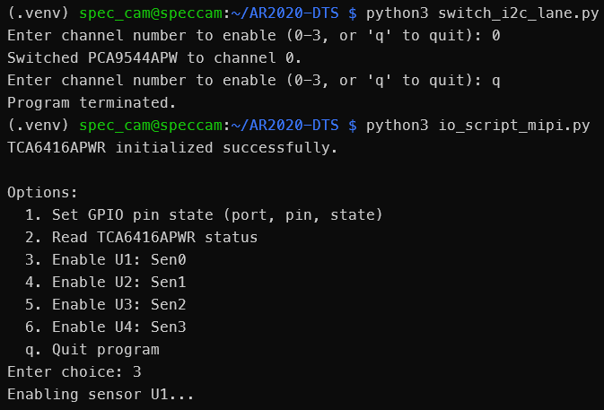
- Result Enable: I2C Scan found 0x36:
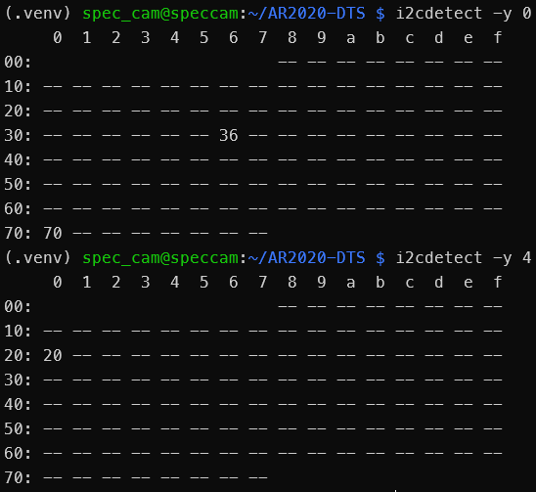

- Install linux Header
sudo apt update && sudo apt install -y git bc build-essential bison flex libssl-dev raspberrypi-kernel-headers

git clone --depth=1 -b rpi-6.12.y https://github.com/raspberrypi/linux.git && cd linux

make bcm2711_defconfig

- Add Driver to Kernel
- Copy “ar2020.c” to “ /home/${USER}/linux/drivers/media/i2c ”
- Edit Kconfig:
sudo nano /home/${USER}/linux/drivers/media/i2c/Kconfig

+ Add these lines:
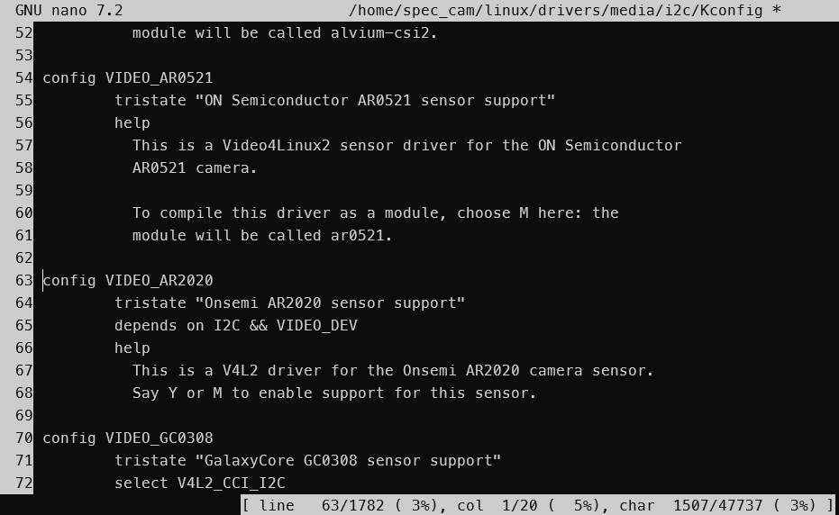

config VIDEO_AR2020
tristate "Onsemi AR2020 sensor support"
depends on I2C && VIDEO_DEV
help
This is a V4L2 driver for the Onsemi AR2020 camera sensor.
Say Y or M to enable support for this sensor.
- Edit Makefile:
sudo nano /home/${USER}/linux/drivers/media/i2c/Makefile

+ Add this line:
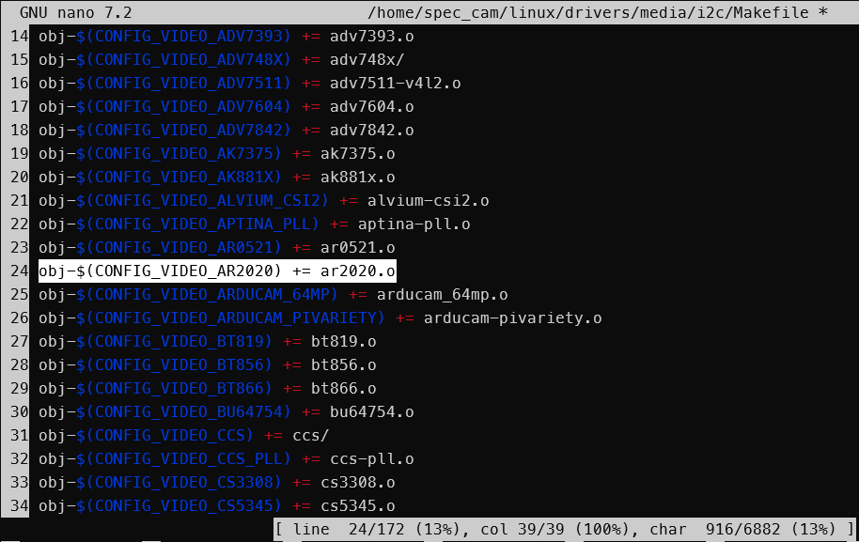
obj-$(CONFIG_VIDEO_AR2020) += ar2020.o

- Build Driver
cd /home/${USER}/linux

make -C /lib/modules/$(uname -r)/build M=$(pwd)/drivers/media/i2c modules CONFIG_VIDEO_AR2020=m
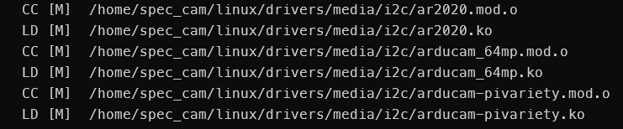
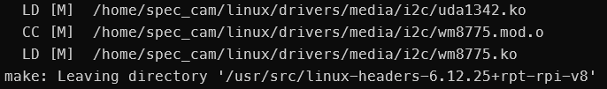
sudo cp drivers/media/i2c/ar2020.ko /lib/modules/$(uname -r)/kernel/drivers/media/i2c/
sudo depmod -a
sudo modprobe -r ar2020
sudo modprobe ar2020
- Done: 🡪 sudo reboot

- Capture 1 raw image:
v4l2-ctl --device=/dev/video0 --set-fmt-video=width=5120,height=3840,pixelformat=pBAA
v4l2-ctl --device=/dev/video0 --set-fmt-video=pixelformat=pBAA --stream-mmap --stream-count=1 --stream-to=output.raw
<
- Change parameter:

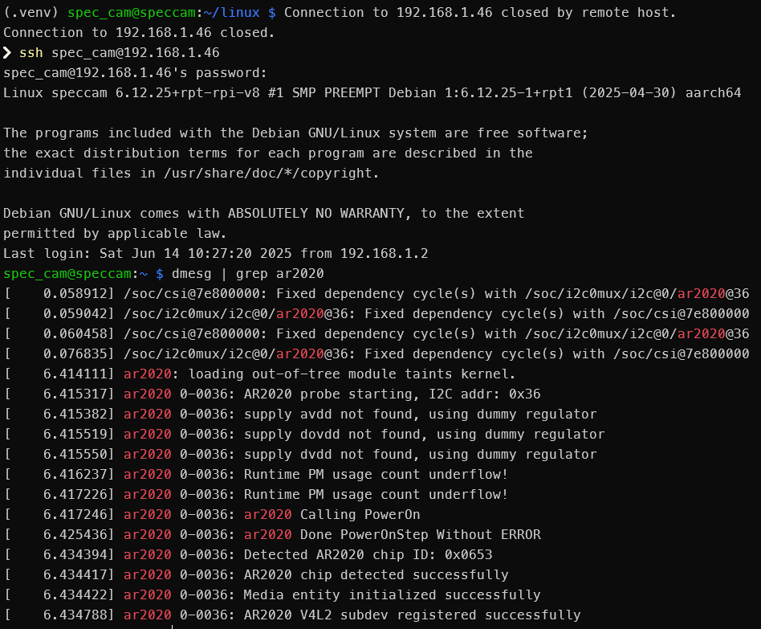
v4l2-ctl -d /dev/video0 --set-ctrl=test_pattern=0
v4l2-ctl -d /dev/video0 --set-ctrl=exposure=100
v4l2-ctl -d /dev/video0 --set-ctrl=analogue_gain=0

- Decode RAW10 using python:
python raweye.py output.raw -H 3840 -b grbg
python raweye.py output.raw -H 3840 -b grbg -o output.jpeg/.png

